1. what Drugres did teaxs used?

SELECT DRUGRES, COUNT(*) AS test_count

FROM `bigquery-public-data.dataflix_traffic_safety.drugs`

WHERE STATE = 'Texas'

GROUP BY DRUGRES

ORDER BY test_count DESC;

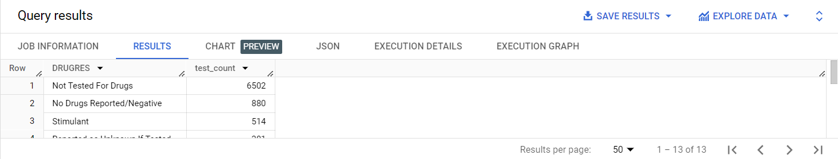

2. What Drugres did Alabama used?

SELECT DRUGRES, COUNT(*) AS test_count

FROM `bigquery-public-data.dataflix_traffic_safety.drugs`

WHERE STATE = 'Alabama'

GROUP BY DRUGRES

ORDER BY test_count DESC;

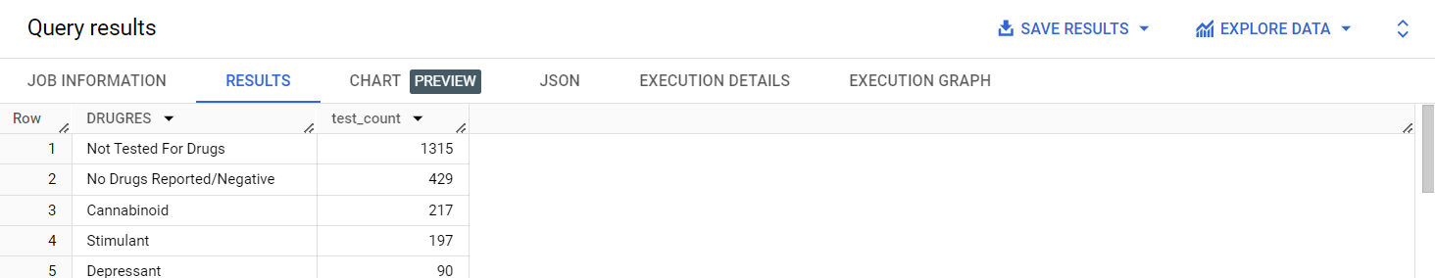

3. What is the ST_CASE number of ohio?

SELECT ST_CASE

FROM `bigquery-public-data.dataflix_traffic_safety.drugs`

WHERE STATE = 'Ohio'

LIMIT 1;

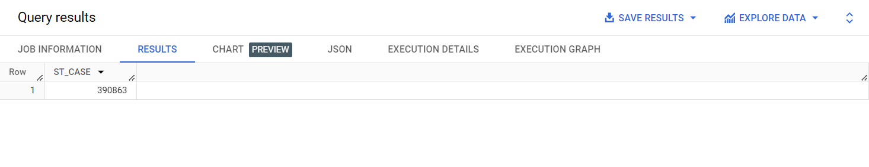

4.which Drugspec is used by tennessee?

SELECT DRUGSPEC

FROM `bigquery-public-data.dataflix_traffic_safety.drugs`

WHERE STATE = 'Tennessee'

LIMIT 1;

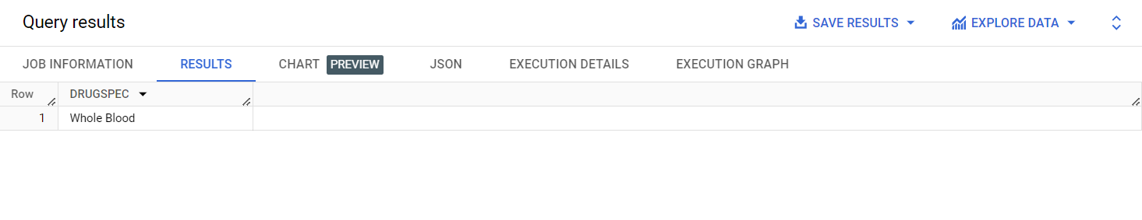

5. What is the VEH_NO of New jersey?

SELECT VEH_NO

FROM `bigquery-public-data.dataflix_traffic_safety.drugs`

WHERE STATE = 'New Jersey'

LIMIT 1;

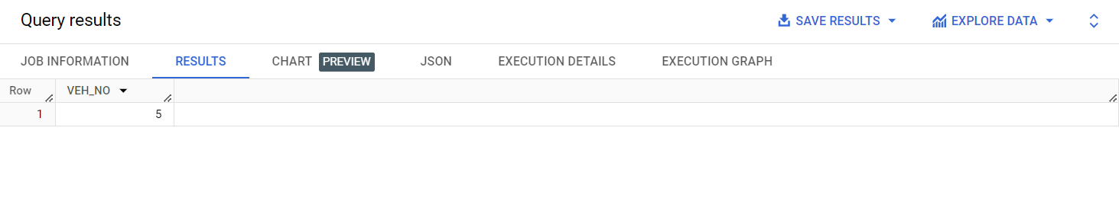

6.What is the DATE_PARTITION of Florida

SELECT DATE_PARTITION

FROM `bigquery-public-data.dataflix_traffic_safety.drugs`

WHERE STATE = 'Florida'

LIMIT 1;

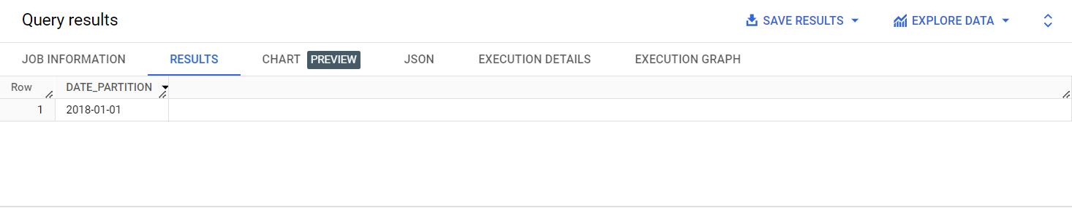

7.what is the ST_CASE of Arizona?

SELECT ST_CASE

FROM `bigquery-public-data.dataflix_traffic_safety.drugs`

WHERE STATE = 'Arizona'

LIMIT 1;

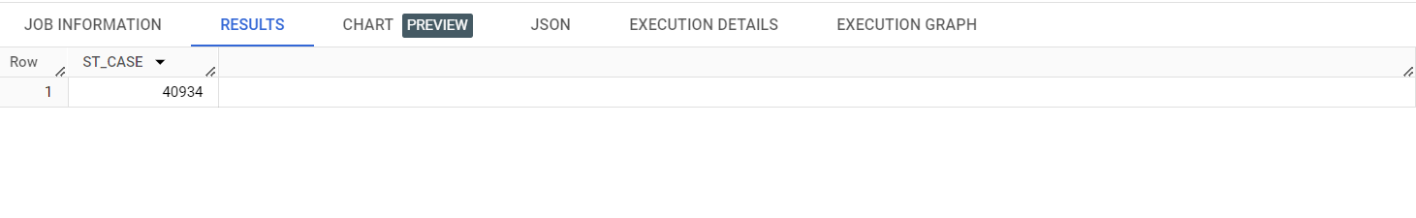

8. What is the DRUGSPEC used by West Virginia?

SELECT DRUGSPEC

FROM `bigquery-public-data.dataflix_traffic_safety.drugs`

WHERE STATE = 'West Virginia'

LIMIT 1;

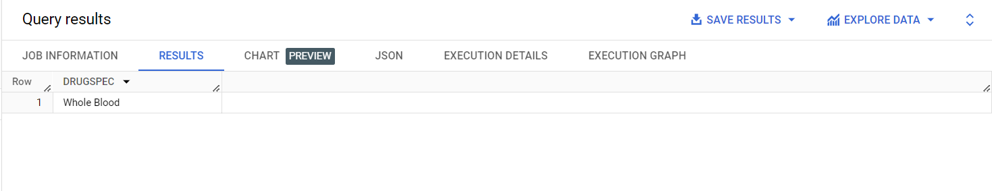

Joint SQL Code:

9. List distracted driving incidents and associated damages

SELECT d.*, dmg.*

FROM `bigquery-public-data.dataflix_traffic_safety.distract` AS d

JOIN `bigquery-public-data.dataflix_traffic_safety.damage` AS dmg

ON d.ST_CASE = dmg.ST_CASE

LIMIT 5;

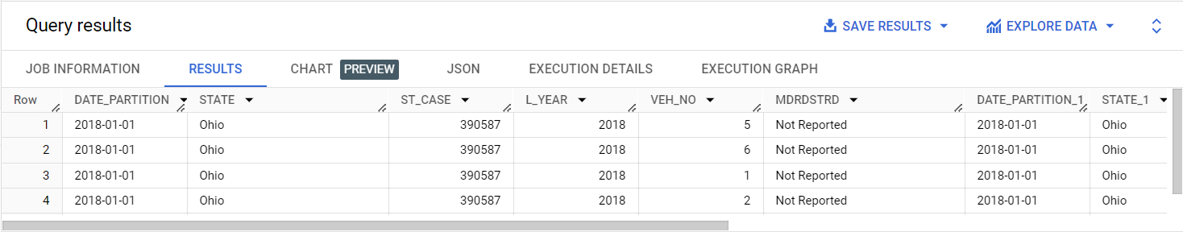

10.List the Common STATE and ST_CASE from joint data?

SELECT d.STATE, COUNT(*) As ST_CASE

FROM `bigquery-public-data.dataflix_traffic_safety.distract` AS d

JOIN `bigquery-public-data.dataflix_traffic_safety.damage` AS dmg

ON d.ST_CASE = dmg.ST_CASE

GROUP BY d.STATE

ORDER BY ST_CASE DESC

Limit 5;

